需求11.06

1、UI增加RRU类型选择：(FZHJ/FZHJ-b/FZHI) /其它

2、FZHJ/FZHJ-b/FZHI 我们已经实现，就是用telnet 192.168.253.196 2323的方法用sfp –i 0的方法取，我们已经实现功能

3、其它RRU方法如下：（FSMF和FSIH有区别）

FSMF:

直接SSH到FCT 192.168.255.1 端口15001

cd /flash 转到flash文件夹

cp -f sfp_tool.tar / 剪切文件 (-f强制覆盖) mv -f sfp_tool.tar ../

cd .. 回到上层文件夹

tar xvf sfp_tool.tar 解压缩文件

chmod +x sfp_tool 修改权限

./sfp_tool –v 读取SFP信息

FSIH:

SSH到FCT 192.168.255.1端口15001 后再ssh [toor4nsn@192.168.253.18](mailto:toor4nsn@192.168.253.18) 端口22 密码 oZPS0POrRieRtu

（这里要注意：最多有3块FBIHFSP，地址分别为.18/.19/.20 要分别查询）

FBIH1 /FBBA1 (192.168.253.19) FBIH2 /FBBA2 (192.168.253.20)

root@FSPM1:~ >cd /flash

root@FSPM1:/flash >cp -f sfp_tool.tar /

root@FSPM1:/flash >cd ..

root@FSPM1:/ >tar xvf sfp_tool.tar

sfp_tool

root@FSPM1:/ >chmod +x sfp_tool

root@FSPM1:/ >./sfp_tool -v

返回 到 FCT用exit

**下面是查询结果：只有sfp_0 、sfp_1有数据**

list = Not listing devices

interface = NOT_DEFINED

info = No

poll = No

poll period = -1

hotplug = No

rx_los = No

mod_abs = No

tx_fault = No

scan = No

diagnose = Yes

----------------------------

We are running on CONFIG_FCT board

Scanning all existing SFPs

DDAL_SFP_0 -> Present, info:

Vendor: WTD -----------------供应商名称

Part number: RTXM228-618

Revision: 1.0 `

鄨

Serial: FR134902558 --------------------------供应商序列号

Connector: 7

Bitrate: 61 --------光口速率6100

Bitrate (Upper): 5

Bitrate (Lower): 5

Wavelength: 1310 ---波长

Compliance Code: 3

Temperature = 39.164062, coherency = 0

Input power = 0.367300, coherency = 0

Input power in dbm = -4.349791

Output power = 0.579600, coherency = 0

Output power in dbm = -2.368716

Voltage = 3.324600, coherency = 0

Current = 36.234001, coherency = 0

DDAL_SFP_1 -> Present, info:

Vendor: WTD

Part number: RTXM228-618

Revision: 1.0 `

鄨

Serial: FR130303767

Connector: 7

Bitrate: 61

Bitrate (Upper): 5

Bitrate (Lower): 5

Wavelength: 1310

Compliance Code: 3

Temperature = 39.164062, coherency = 0

Input power = 0.667500, coherency = 0

Input power in dbm = -1.755488

Output power = 0.554800, coherency = 0

Output power in dbm = -2.558636

Voltage = 3.354100, coherency = 0

Current = 40.194000, coherency = 0

DDAL_SFP_2 -> Not present

DDAL_SFP_3 -> Not present

DDAL_SFP_4 -> Not present

DDAL_SFP_5 -> Not present

DDAL_SFP_6 -> Not present

DDAL_SFP_7 -> Not present

DDAL_SFP_8 -> Not present

DDAL_SFP_9 -> Not present

DDAL_SFP_10 -> Not present

DDAL_SFP_11 -> Not present

DDAL_SFP_DEV_LOCAL_RADIO_IF_1 -> Present, info:

Vendor: WTD 供应商

Part number: RTXM228-618

Revision: 1.0 `

鄨

Serial: FR134902558 供应商序列号

Connector: 7

Bitrate: 61 --光口速率

Bitrate (Upper): 5

Bitrate (Lower): 5

Wavelength: 1310 --波长

Compliance Code: 3

Temperature = 39.328125, coherency = 0 --温度

Input power = 0.367300, coherency = 0 --输入功率

Input power in dbm = -4.349791

Output power = 0.579600, coherency = 0 --输出功率

Output power in dbm = -2.368716

Voltage = 3.324600, coherency = 0

Current = 36.036003, coherency = 0

DDAL_SFP_DEV_LOCAL_RADIO_IF_2 -> Present, info:

Vendor: WTD

Part number: RTXM228-618

Revision: 1.0 `

鄨

Serial: FR130303767

Connector: 7

Bitrate: 61

Bitrate (Upper): 5

Bitrate (Lower): 5

Wavelength: 1310

Compliance Code: 3

Temperature = 39.164062, coherency = 0

Input power = 0.667500, coherency = 0

Input power in dbm = -1.755488

Output power = 0.552900, coherency = 0

Output power in dbm = -2.573534

Voltage = 3.354100, coherency = 0

Current = 40.194000, coherency = 0

DDAL_SFP_DEV_LOCAL_RADIO_IF_3 -> Not present

DDAL_SFP_DEV_LOCAL_RADIO_IF_4 -> Not present

DDAL_SFP_DEV_LOCAL_RADIO_IF_5 -> Not present

DDAL_SFP_DEV_LOCAL_SHARED_1 -> Not present

DDAL_SFP_DEV_LOCAL_SRIO_1 -> Not present

DDAL_SFP_DEV_LOCAL_SRIO_2 -> Not present

DDAL_SFP_DEV_LOCAL_TRS_1 -> Not present

DDAL_SFP_DEV_LOCAL_TRS_2 -> Not present

DDAL_SFP_DEV_FSP_1_SRIO_1 -> Not present

DDAL_SFP_DEV_FSP_1_SRIO_2 -> Not present

DDAL_SFP_DEV_FSP_2_SRIO_1 -> Not present

DDAL_SFP_DEV_FSP_3_SRIO_1 -> Not present

DDAL_SFP_DEV_FSP_2_SRIO_2 -> Not present

DDAL_SFP_DEV_FSP_3_SRIO_2 -> Not present

DDAL_SFP_DEV_FSP_2_RADIO_IF_1 -> Not present

DDAL_SFP_DEV_FSP_3_RADIO_IF_1 -> Not present

DDAL_SFP_DEV_FTM_TRS_1 -> Not present

DDAL_SFP_DEV_FTM_TRS_2 -> Not present

DDAL_SFP_DEV_FTM_SRIO_1 -> Not present

root@FSPM1:/ >

4.增加一个界面显示拓扑图（先不详细到节点映射，只要显示BBU-RRU是否同步即可，就像下面的图，忽略节点），方法如下：

IP?

(192.168.255.1 )

FSMF在FCT下执行，FSIH在FSP下执行，跟以前一样

(

登陆的步骤:

)

cat /sys/class/flexi/rp3_01_link0/rx_sm/state

0x3  备注：查询RX帧状态，0x3表示RX帧同步（BBU-RRU用绿线连接），0x0表示RX帧失步（BBU-RRU用红线连接）

cat /sys/class/flexi/rp3_01_link0/rx_lcv/err_cnt

0x0 备注：查询当前误码，0x0表示没有误码，其它值表示存在误码

cat /sys/class/flexi/rp3_01_link0/rx_lcv/err_cnt_tot

0x90ffc52d 备注：查询总误码

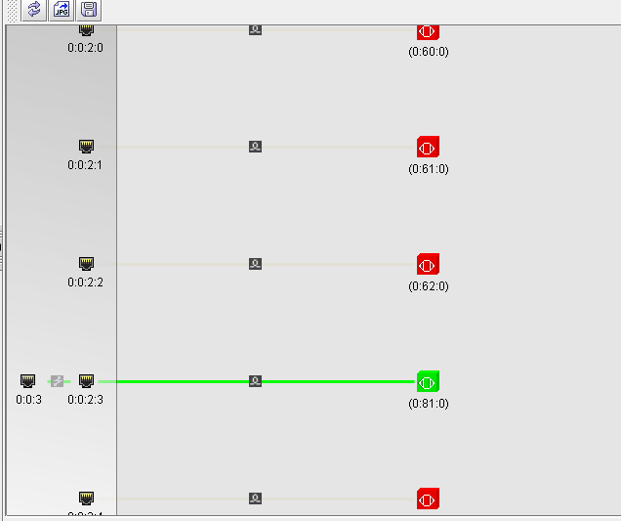

DDAL_SFP_0