厂区安防监控系统
Factory security monitoring system
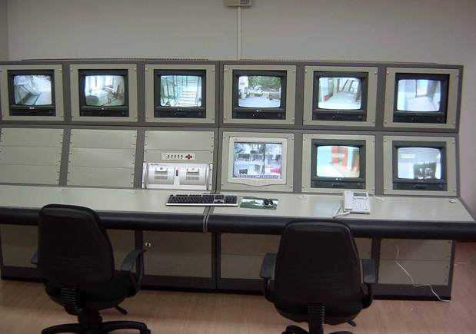

With the acceleration of the rhythm of people's lives, increasing work pressure, people want more stability and a comfortable life.Life safety of the working environment more and more attention. As the sensor technology, control technology, the continuous development of computer technology, security measures to guard against the high iron gate from the development to the present can not see the wall, the safety factor is several times the original. But the technology is still in development stage, it is also a variety of products, good buckwheat missing. Design a higher factor of safety, and security prices lower system very important.
随着人们生活节奏的加快，工作压力的不断增加，人们越来越渴望安定舒适的生活，生活工作环境的安全问题越来越受到人们的重视。由于传感技术、控制技术、计算机技术的不断发展，安全的防范的措施由原来的高墙铁门发展到现在的看不到的墙，安全系数是原来的几倍。但是此项技术尚处于发展阶段，所以产品也是各种各样，良荞不齐。设计一套安全系数较高，而且价格较低的安全防范系统有很重要的意义。
This article's main task is to design the fire control system, burglar alarm systems and perimeter defense systems and subsystems to achieve the three systems.
这个系统主要包括是设计和安装火灾监控系统、防盗报警系统和周边防护系统，并实现三个子系统的系统集成。
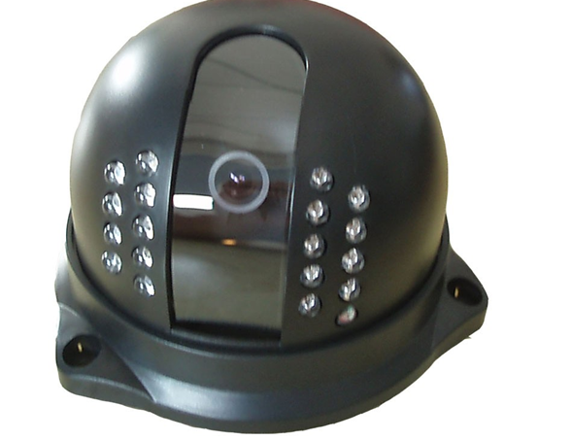

By the whole system is divided into an outdoor space, indoor two parts. Selection of active outdoor infrared detectors, active infrared transmitter sent a bouquet of the infrared beam by the modulation, into the infrared receiver to form a cordon. Around the protection system in order to be able to be integrated into the central control system, active infrared detector system access to the PLC by the PLC system will be around the protection system of information transmission to the central control system. Indoor selected JB-R21-SG (1020 / 2 system) linkage-type fire alarm controller, fire alarm and set in one linkage control. Central control system is a computer, using the configuration software, the electronic map display as well as the regional board and collected the information of the subsystems of system integration. When abnormal events occur, the computer control system for the issue of sound and light alarm, and warning instructions on the computer were taking place, such as information, the realization of the intelligent monitoring of the environment.
整个系统按空间划分为室外、室内两部分。室外选用主动式红外探测器，主动红外发射器发出一束经调制的红外光束，投向红外接收器，形成一条警戒线。为了能将周边防护系统集成到中央控制系统中，主动红外探测器接入到PLC系统，由PLC系统将周边防护系统的信息传送到中央控制系统。室内选用JB-R21-SG(1020/2系统)联动型火灾报警控制器，集火灾报警和联动控制于一体。中央控制系统是一台计算机，采用组态软件，对电子地图板和区域显示器以及采集到的各子系统信息进行系统集成。当异常事件发生时，控制系统的计算机发出声光报警，并在计算机上指示警报发生的地点之类信息，实现对整个环境的智能监控。

